**Prototype-CPL**

|  |  |
| --- | --- |
| **Student Name/ID Number:** | Agung Yuda Pratama / BDSE07-0922-076 |
| **Academic Year:** | 2022 |
| **Unit Assessor:** | Arvinder Kaur |
| **Project Title:** | CPL-Project prototype |
| **Issue Date:** | 07 September 2023 |
| **Submission Date:** | 07 September 2023 |
| **Internal Verifier Name:** |  |
| **Date:** | 07 September 2023 |

|  |
| --- |
| **Learner declaration** |
| I certify that the work submitted for this assignment is my own and research sources are fully acknowledged.    07 September 2023  Student signature: Date: |

**LANDING PAGE**

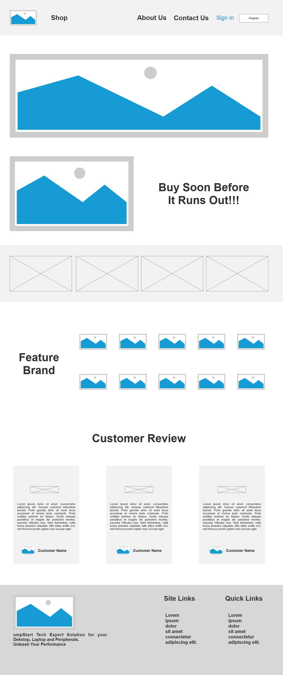

**ABOUT US**

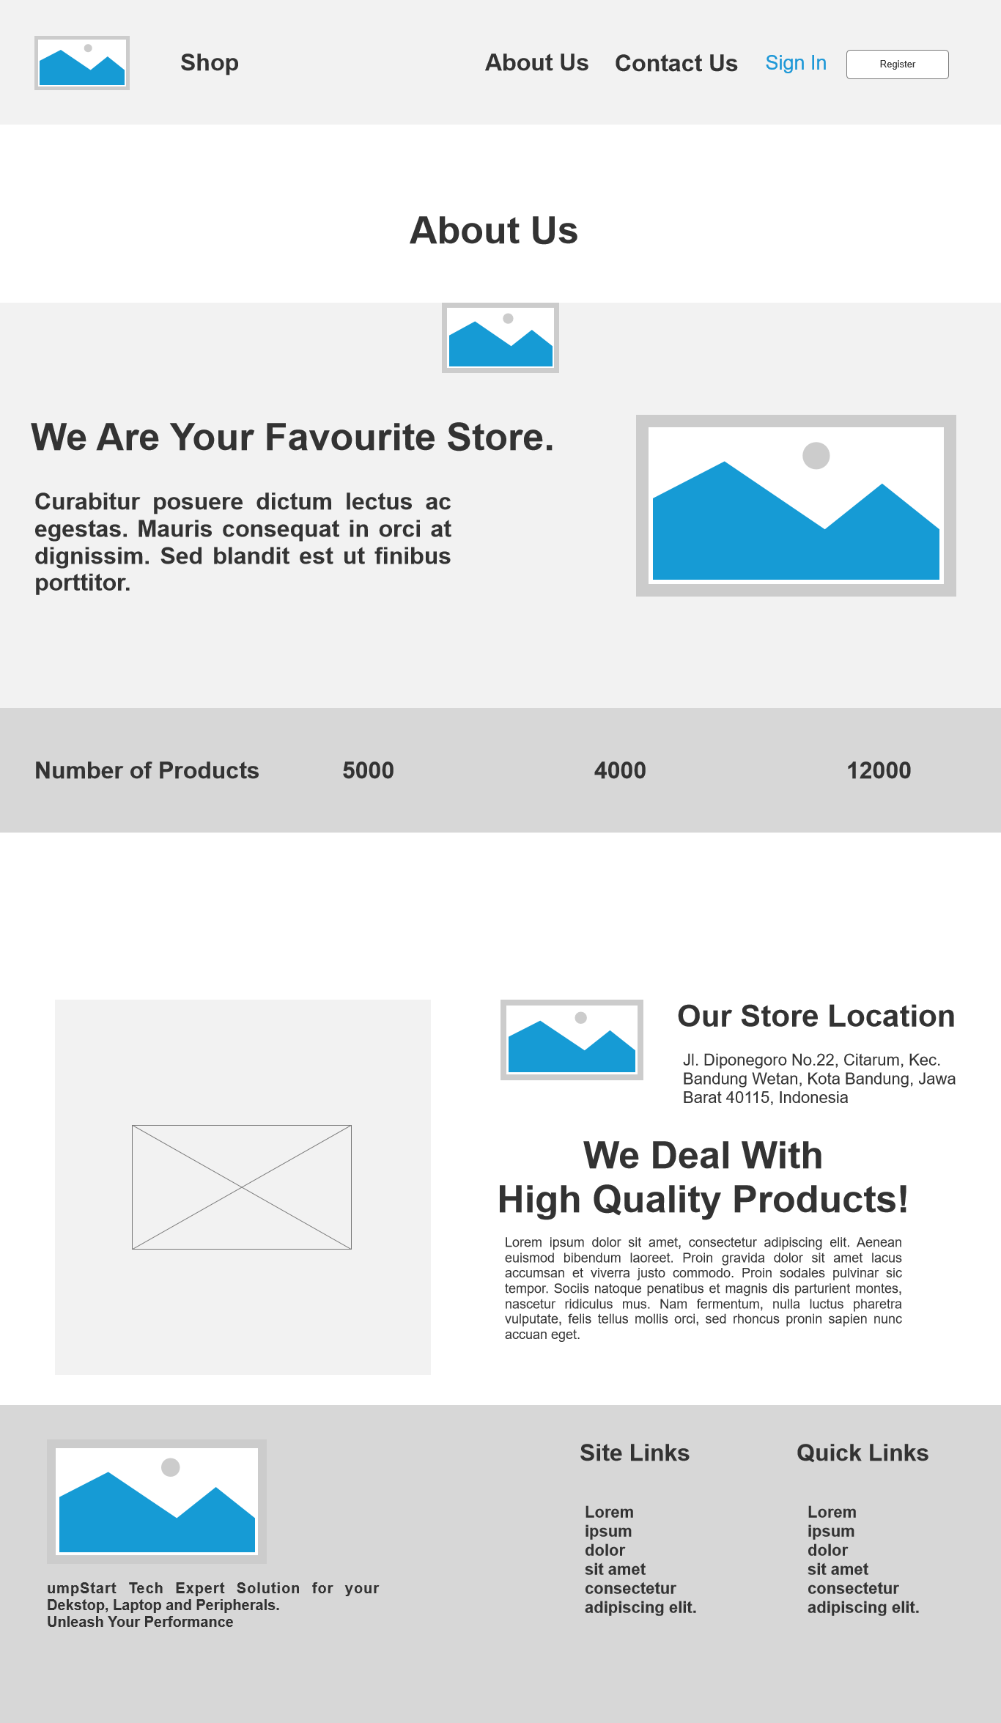

**CONTACT US**

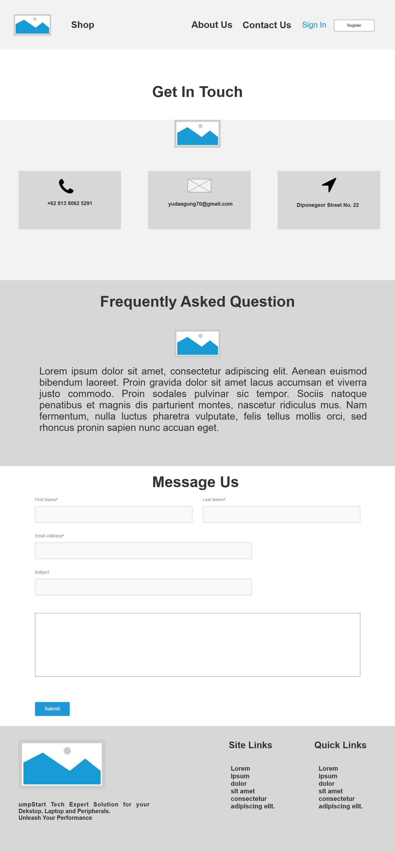

**PRIVACY POLICY**

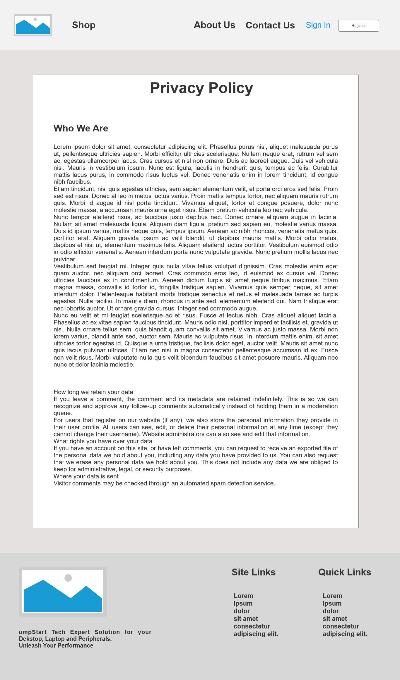

**REFUND AND RETURN POLICY**

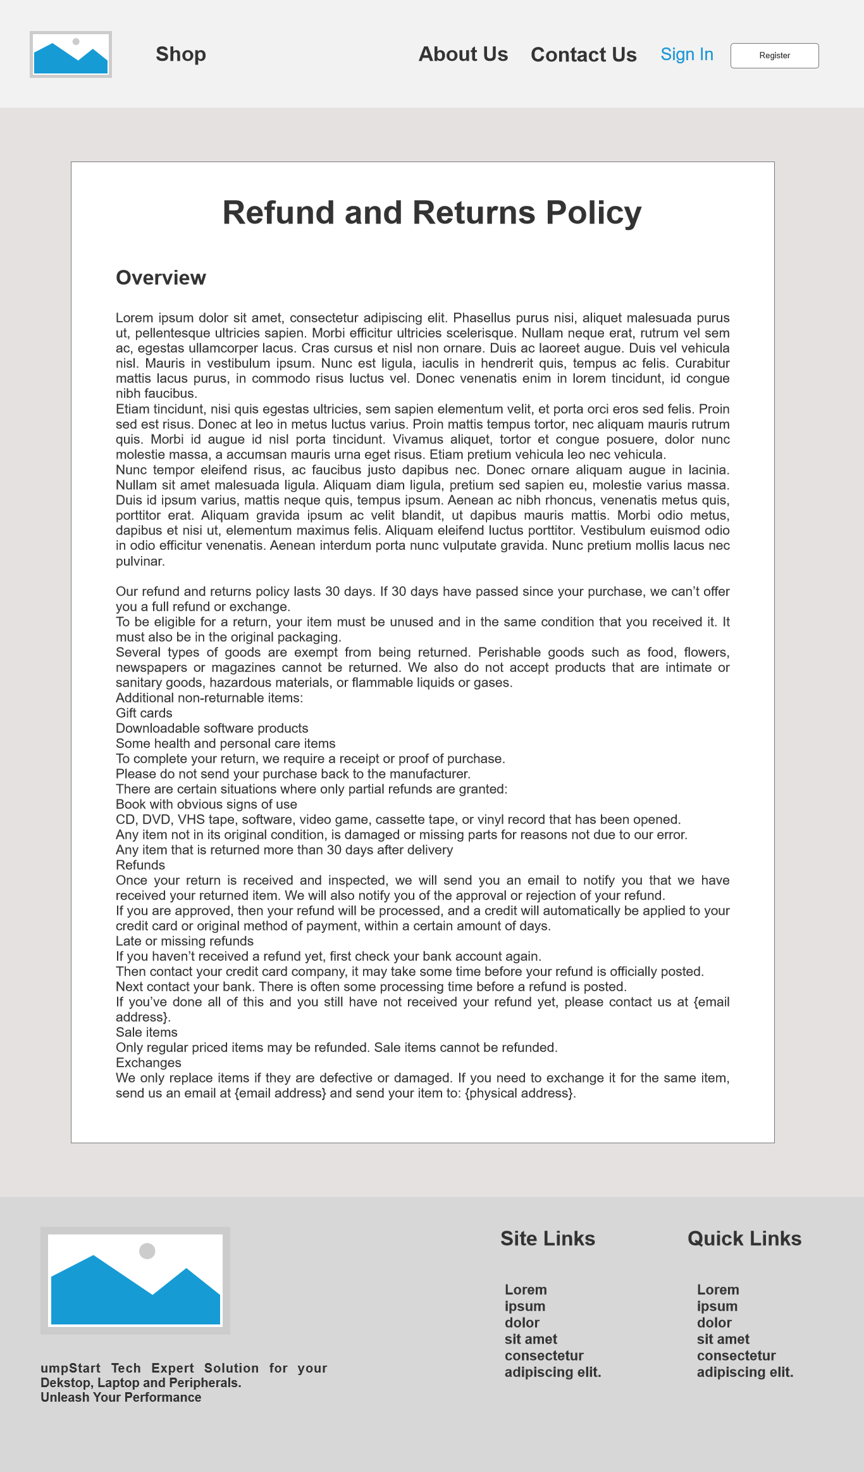

**REGISTER**

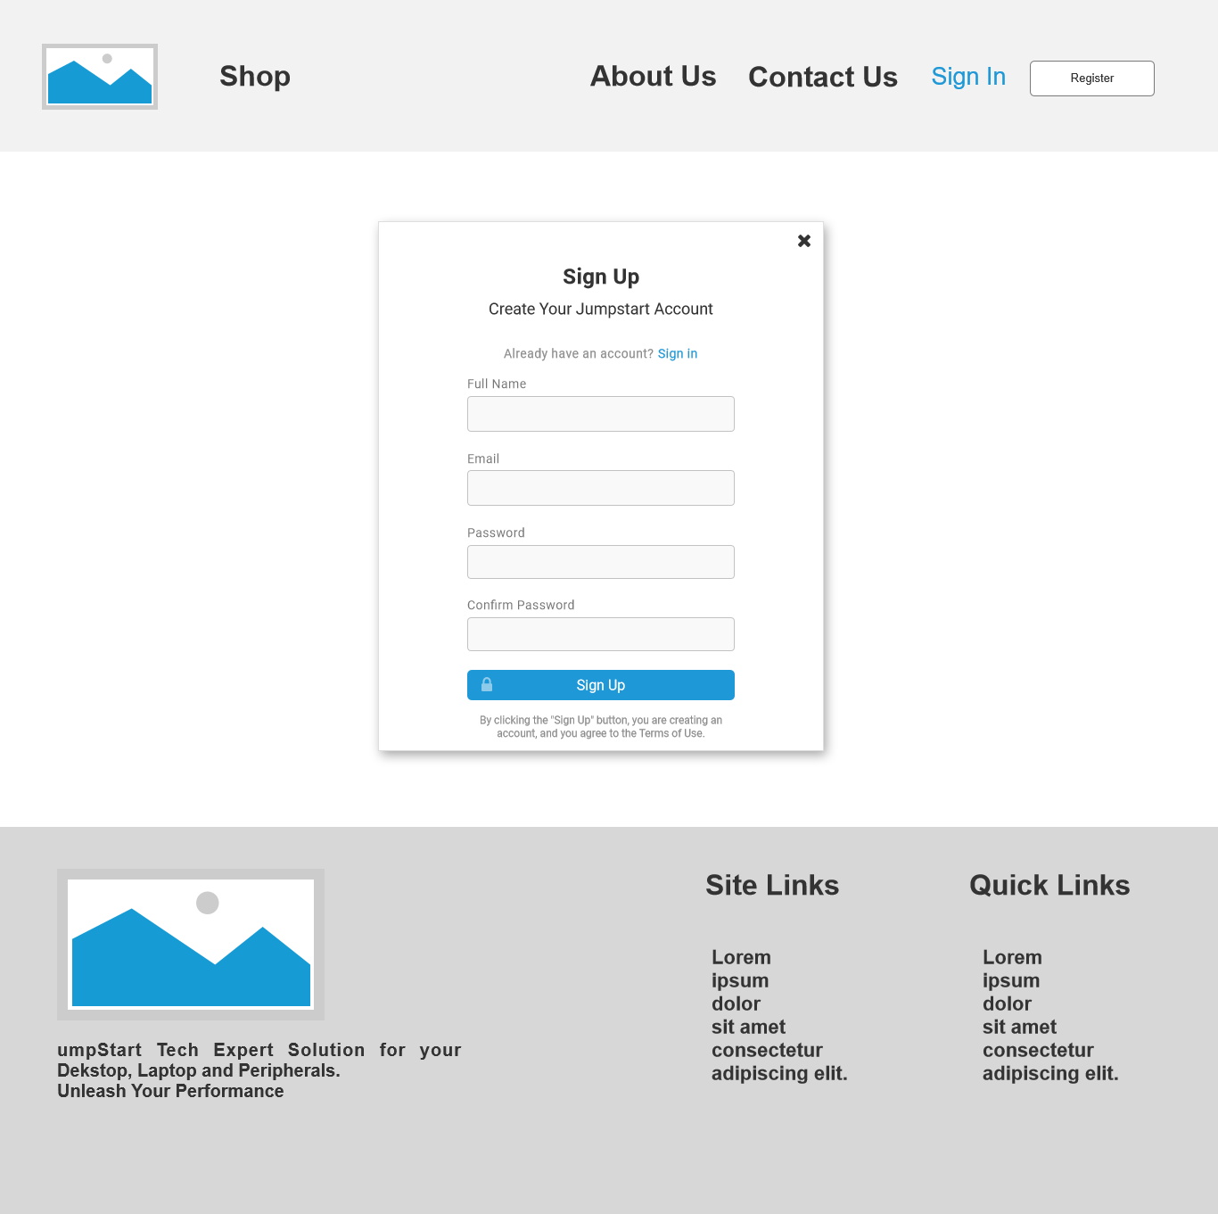

**LOGIN**

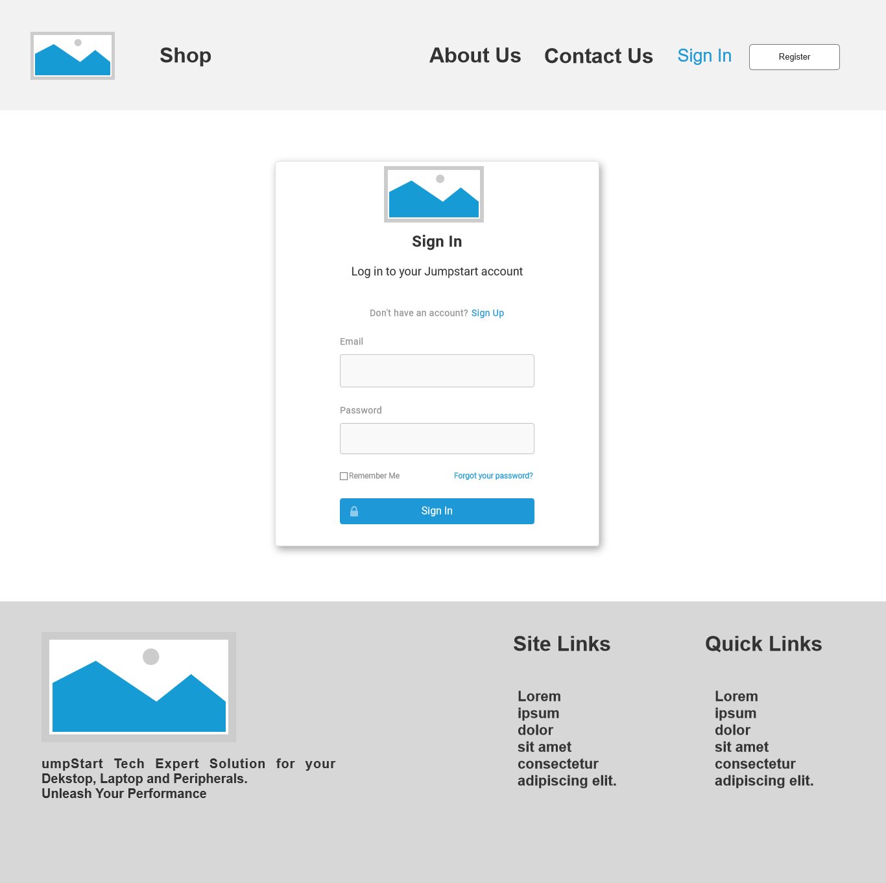

**SHOP**

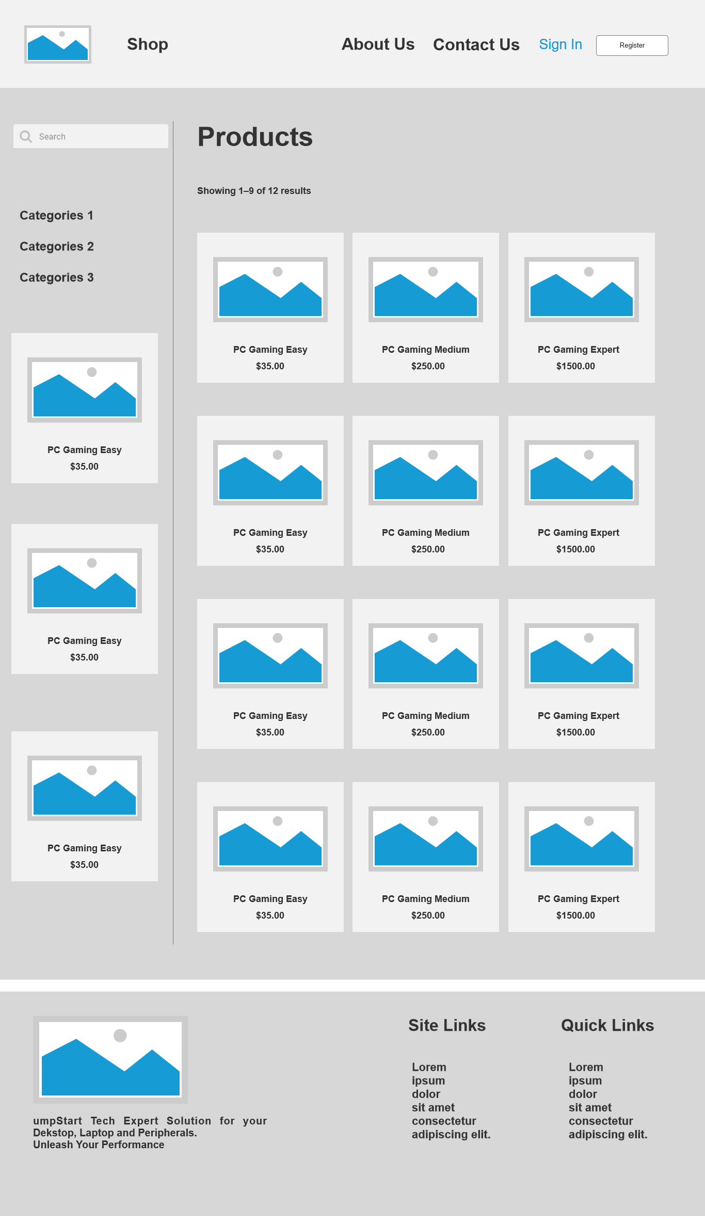

**PRODUCT DETAIL**

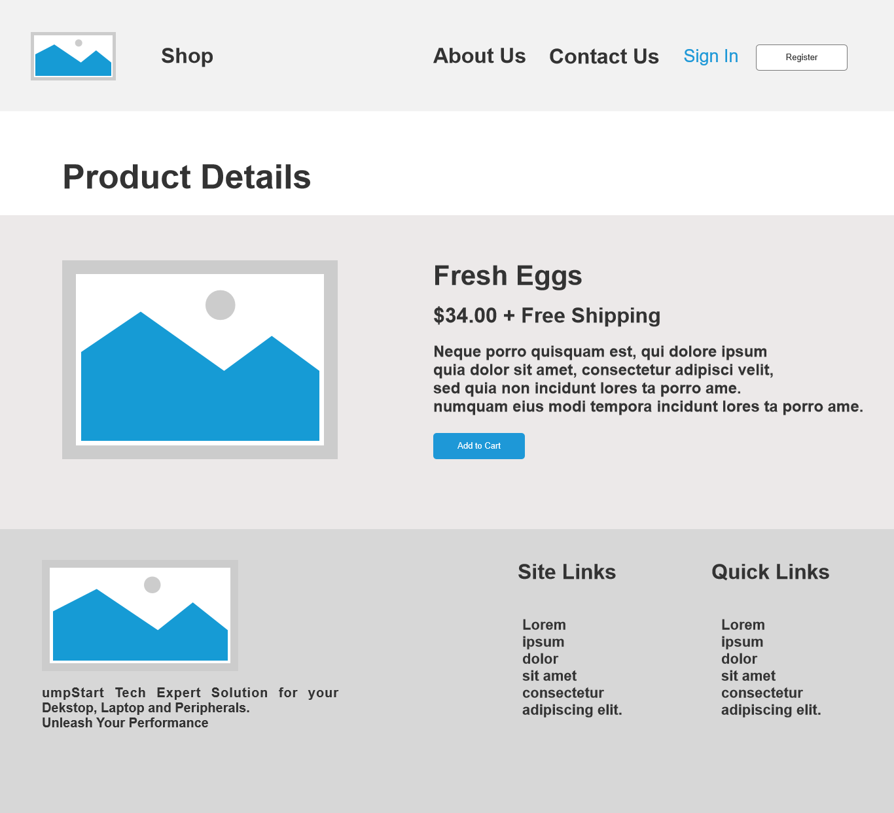

**CART**

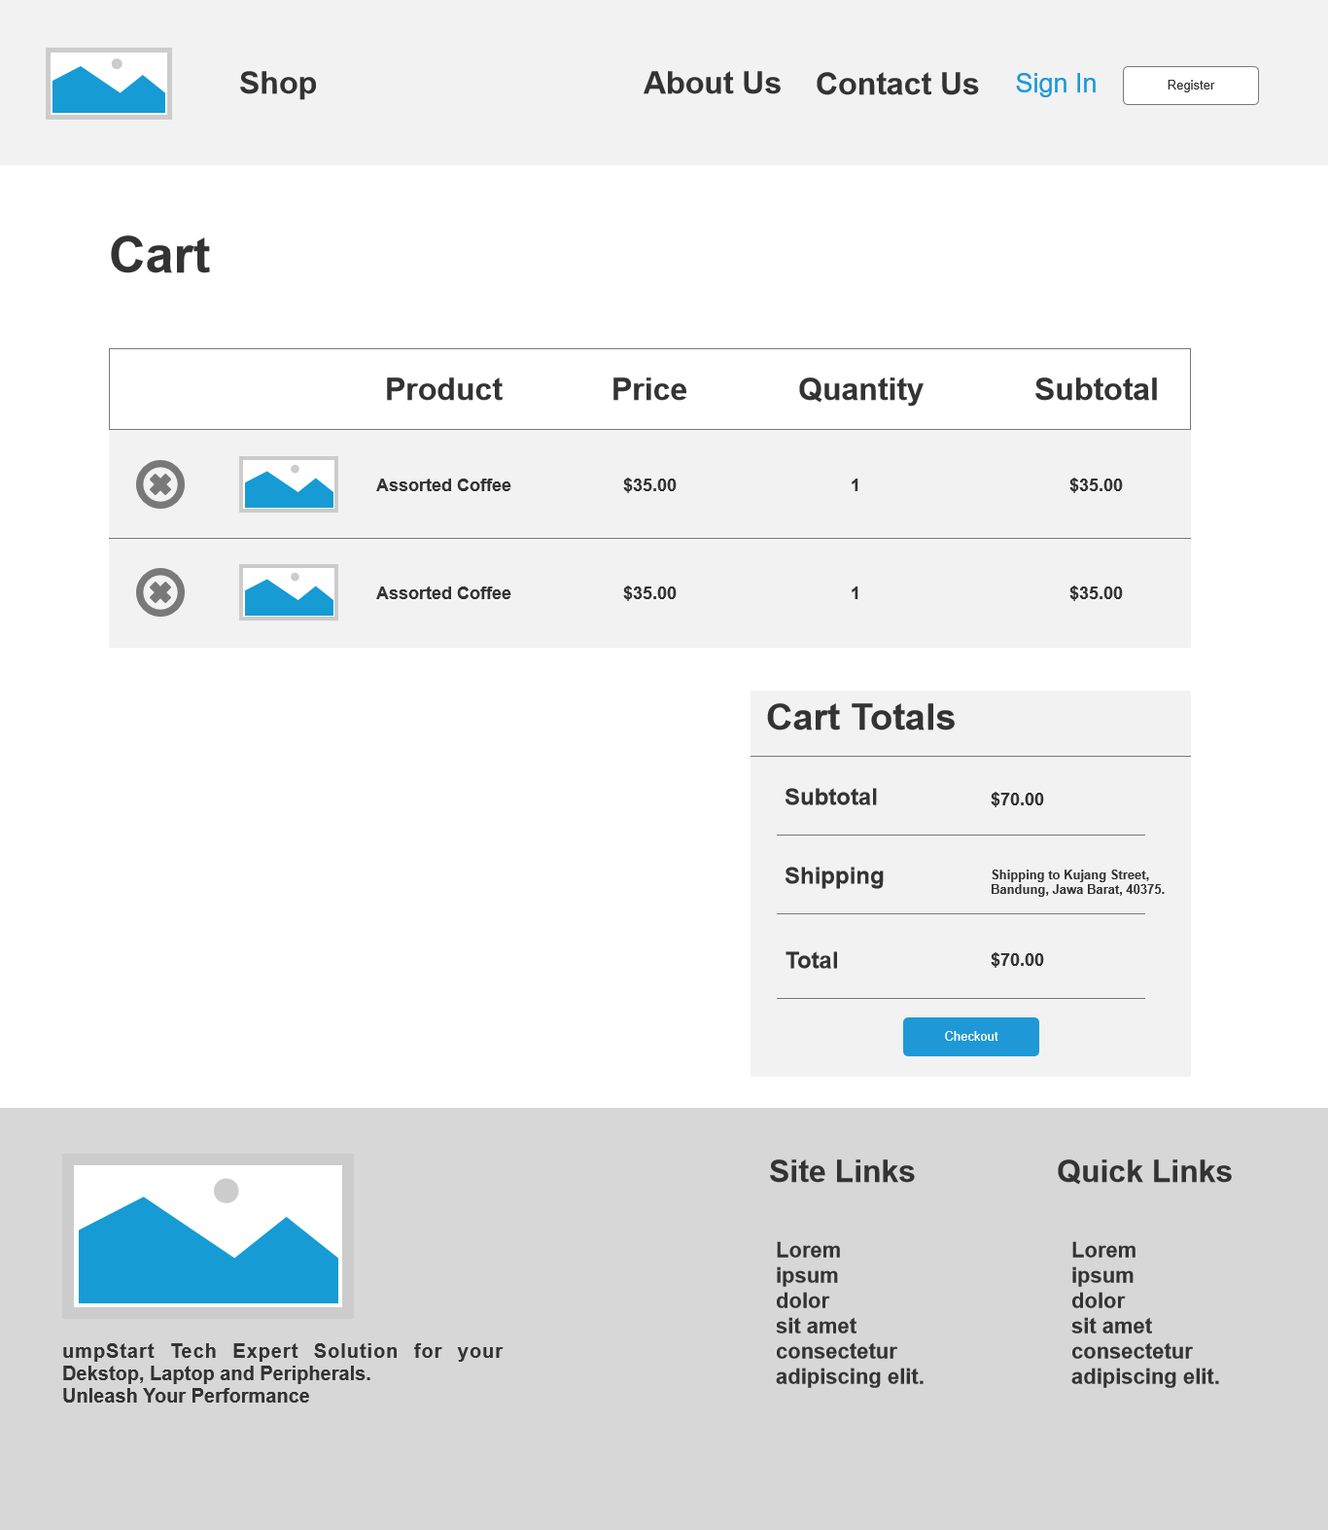

**CHECKOUT**

